**HCI Project**

**OSU Shuttle app**

**Project Part 2: Heuristics Assignment**

**Team Members:**

Aswin Pratap Mullankandi

Dharun Narayanan Lakshminarayanan Komethagavelu

Santhos Kamal Arumugam Balamurugan

Sai Balaji Neeli

**Name of the “Patient” project:** OSU Shuttle app

**The scenario being evaluated:**

Scenario 2:

Abi needs to get to her doctor's appointment at the Benton County Health Services in afternoon after her classes. She opens the app and searches for routes that go between class from ILLC and Benton County Health Services. The app not only displays the schedule and route for the OSU shuttle system, but also integrates information about the Corvallis LBCC bus network. It shows Abi that she can take the orange OSU shuttle to a transfer point, then connect to a Corvallis bus that will take her directly to the Benton County Health Services. The app provides the estimated travel times for this combined shuttle and bus trip, as well as the number of transfers required. Considering factors like total travel duration and convenience, the app recommends this multi-modal route as the most efficient option for Abi's commute.

**Workflow of this scenario:**

1. User opens the OSU Shuttle app:

* The app displays the home screen, which features a live map showing the current location of the shuttles and a search bar for finding specific routes or destinations.
* The home screen also includes quick access buttons for popular destinations, such as the OSU campus, downtown Corvallis, and major transit hubs.

1. The user navigates to the search bar menu within the app to input the destination: Benton County Health Services.

* The user taps on the search bar, which expands to reveal a full-screen search interface.
* The user begins typing "Benton County Health Services" into the search bar, and the app provides auto-complete suggestions based on their input.
* The user selects "Benton County Health Services" from the auto-complete suggestions.

1. After entering the destination, the app displays the available bus routes that pass through or near Benton County Health Services, including the OSU shuttle system and Corvallis LBCC bus network.

* The app presents a list of route options, sorted by estimated travel time and number of transfers required.
* Each route option includes a summary of the journey, such as "OSU Shuttle to Transfer Point + Corvallis Bus to Destination" or "OSU Shuttle Direct to Destination."
* The app also displays the estimated departure and arrival times for each route option.

1. The user selects the route that involves taking the OSU shuttle to a transfer point, then connecting to a Corvallis bus.

* The user taps on the route option that includes the transfer from the OSU shuttle to the Corvallis bus.
* The app expands the selected route to show more detailed information, such as the specific OSU shuttle and Corvallis bus routes involved, the location of the transfer point, and any walking directions needed to complete the journey.

1. The app provides detailed information about the selected route, including the schedule, estimated travel times, and number of transfers required.

* The app displays a step-by-step breakdown of the selected route, including the estimated times for each step of the journey (e.g., "OSU Shuttle: 10 minutes," "Transfer: 5 minutes," "Corvallis Bus: 15 minutes").
* The app also shows the total estimated travel time for the entire journey.
* The user can view the specific schedules for the OSU shuttle and Corvallis bus routes involved in their journey, including the frequency of service and any potential delays or disruptions.

1. Based on factors like total travel duration and convenience, the app recommends the selected multi-modal route as the most efficient option for the user's commute.

* The app displays a message confirming that the selected route is the recommended option based on the user's preferences and current traffic conditions.
* The app provides a comparison of the selected route to alternative options, highlighting the benefits of the recommended route (e.g., "10 minutes faster than the next fastest option").

1. The user confirms the selection, and the app provides confirmation of the chosen route.

* The user taps a "Confirm" button to finalize their route selection.
* The app displays a confirmation screen, which includes a summary of the selected route, the estimated departure and arrival times, and any relevant alerts or notifications (e.g., "Construction work on the Corvallis Bus route may cause slight delays").
* The user can choose to set a reminder for their upcoming journey or add the route to their favorites for easy access in the future.
* The app also provides options for the user to share their planned route with others or export the route details to another app (e.g., a calendar or mapping service).

1. The app redirects the user to the main screen, where they can view their upcoming trip details and access additional features.

* The main screen now displays a summary of the user's upcoming journey, including the estimated departure time, transfer details, and arrival time at Benton County Health Services.
* The user can access additional features from the main screen, such as viewing the real-time location of the OSU shuttle and Corvallis buses involved in their route, setting custom alerts for their journey (e.g., "Notify me when the OSU shuttle is 5 minutes away"), or exploring other transit options for future trips.
* The main screen also includes a "Live Chat" or "Support" button, allowing the user to quickly access help or guidance if needed during their journey.

**WORKFLOW evaluation, Using the GenderMag Heuristics:**

1. Explain the benefits of using new and existing features (Motivations and Attitude Toward Risk):

* For users motivated by task completion (like Abi), the app should highlight the benefits of using the multi-modal route planning feature, such as convenience and efficiency in combining different transportation services to provide shorter travel times and fewer transfers.
* For users motivated by tech interest (like Tim), emphasize the novelty and cutting-edge nature of integrating multiple transportation networks into a single route planner.
* The app should clearly explain the unique benefits of the multi-modal route to cater to different motivations and encourage usage.

1. Explain the costs of using new and existing features (Attitude Toward Risk):

* For risk-averse users (like Abi and Pat), clearly explain any potential costs or risks associated with using multi-modal routes, such as additional fares, longer travel times due to transfers, or the complexity of coordinating multiple transportation services.
* For risk-tolerant users (like Tim), while potential costs or risks may be less of a deterrent, it's still important to provide transparency about any additional effort or time required.
* The app should provide clear information about the effort and time required for the multi-modal route to alleviate risk-averse concerns.

1. Let people gather as much information as they want, and no more than they want (Information-Processing Style):

* For comprehensive information processors (like Abi and Pat), provide detailed information about all available routes, schedules, transfer points, and other relevant details for each multi-modal option.
* For selective information processors (like Tim), present the recommended multi-modal route upfront, but allow them to easily access more comprehensive information if desired.
* The app should allow users who prefer to gather information comprehensively to access detailed information about the multi-modal route, including schedules, transfer points, and step-by-step directions. At the same time, it should also provide a concise summary for users who prefer to process information quickly without overwhelming them.

1. Keep familiar features available (Computer Self-Efficacy and Attitude Toward Risk):
   * For users with low computer self-efficacy (like Abi) and risk-averse users, keep familiar features like separate OSU shuttle route planning alongside the new multi-modal option.
   * For users with high computer self-efficacy (like Tim) and risk-tolerant users, the inclusion of new features may be less of a concern.
   * While introducing the new multi-modal route feature, the app should maintain familiar features for planning trips using the OSU shuttle system. Maintain a consistent and familiar interface with easy access to route search and selection. This can help users with lower computer self-efficacy and those who are risk-averse to continue using the app comfortably.
2. Make undo/redo and backtracking available (Attitude Toward Risk):

* For risk-averse users (like Abi and Pat), provide undo/redo and backtracking options to allow them to easily change their origin, destination, or route preferences without feeling locked into a choice they're unsure about.
* For risk-tolerant users (like Tim), undo/redo may be less of a necessity, but it's still a useful feature to have for correcting mistakes or exploring different options.
* Allow users to easily go back and modify their route selection or view previous steps. The app should provide options to undo or redo route selections, as well as the ability to backtrack to previous screens to modify their route selection. This can help users feel more comfortable exploring the multi-modal route feature, knowing that they can easily revert or try a different option.

1. Provide an explicit path through the task (Learning: by Process vs. Tinkering):

* Users need a clear, step-by-step guide to understand the multi-modal route.
* The app should provide a clear and explicit path for planning a multi-modal trip, guiding users through the necessary steps to enter start and end locations, view route options, and access detailed information to cater to different learning styles.

1. Provide ways to try out different approaches (Computer Self-Efficacy):

* Users like Abi would benefit from alternative routes when feeling unable to proceed with the current one.
* Users like Pat and Tim are willing to try alternative ways of succeeding for a while and try numerous workarounds to get around a problem.
* The app should allow users to explore and compare multiple route options, including single-mode (OSU shuttle only) and multi-modal routes. This can help users with varying levels of computer self-efficacy to find the approach that works best for their needs and preferences.

1. Encourage tinkerers to tinker mindfully (Learning: by Process vs. Tinkering):

* Users like Abi may be risk-averse and hesitant to use unfamiliar features.
* Users like Pat may try out new features mindfully, reflecting on each step.
* Users like Tim should be encouraged not to over-tinker to reduce mistakes and stay on-task.
* While the app should support users who prefer to tinker and explore different route options, it should also provide guidance and reminders to encourage mindful tinkering. This can help prevent users from getting distracted or overwhelmed by too many options, ensuring they stay focused on their goal.

**DETAILED Evaluation:**

1. Home Screen and Search:

Image 1: Home Screen & Image 2: Search for Routes

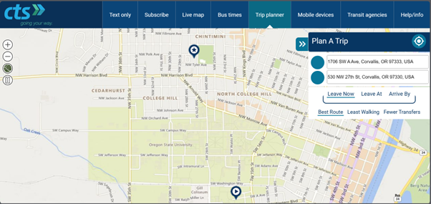Fig 1.1 : Corvallistransit.com – User opens the website and enters ILLC as source and Benton Health services as destination. User can next select his preferred leave at time or arrive by time if preferred and can select fewer transfers/least walking/best route.

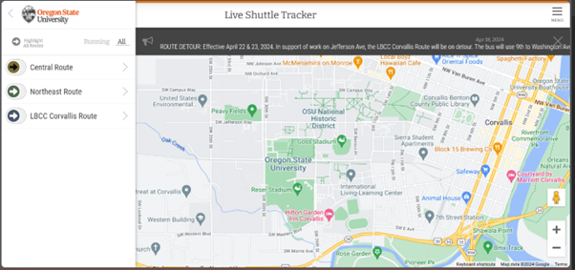Fig 1.2: osushuttles.com – User opens the website and does not have an option to enter source and destination. User can opt one of the given routes. If given permission it pins the current location of the user.

1. Explain the benefits of using new and existing features (Motivations and Attitude Toward Risk):

The home screen does not explicitly explain the benefits of the multi-modal route feature or highlight its unique value proposition. Users may not be motivated to explore this feature if its advantages are unclear.

1. Explain the costs of using new and existing features (Attitude Toward Risk)

The home screen does not provide any information about potential costs or trade-offs associated with using the multi-modal route feature, which may concern risk-averse users. No information is provided about potential costs or trade-offs associated with using the "LBCC Corvallis Route" option, which may concern risk-averse users.

1. Let people gather as much information as they want, and no more than they want (Information-Processing Style)

The home screen is relatively minimal, catering to users who prefer selective information processing. The search screen provides a concise list of route options. However, there are no immediate options for comprehensive information gatherers to access more details about each route.

1. Keep familiar features available (Computer Self-Efficacy and Attitude Toward Risk)

The home screen prominently displays the familiar "Live Shuttle Tracker" map, allowing users with lower self-efficacy or risk-aversion to continue using the app as they have in the past. The search screen displays the familiar "Central Route" and "Northeast Route" options, allowing users with lower self-efficacy or risk-aversion to continue using the app as they have in the past.

1. Make undo/redo and backtracking available (Attitude Toward Risk)

At this stage, no specific undo/redo or backtracking functionality is necessary on the home screen itself.

1. Provide an explicit path through the task (Learning: by Process vs. Tinkering)

The home screen provides a clear starting point with the "Search for a stop" input field, guiding process learners to the next step of entering their desired location. The search screen presents the route options as the next step after entering a location, providing a clear path for process learners to follow.

1. Provide ways to try out different approaches (Computer Self-Efficacy)

The "Search for a stop" input field allows users to explore different location options, by displaying multiple route options, including the "LBCC Corvallis Route," the screen allows users with varying levels of self-efficacy to explore different approaches.

1. Encourage tinkerers to tinker mindfully (Learning: by Process vs. Tinkering)

While tinkerers may be inclined to try different location inputs or select different route options, the home screen or the search screen does not provide specific guidance or reminders to help them focus on meaningful locations relevant to their commute needs.

1. Results Screen and Map View:

Image 1: Result Screen - LBCC Corvallis Route, Image2: Result Screen - Northeast Route & Image3: Result Screen - Northeast Route with current location

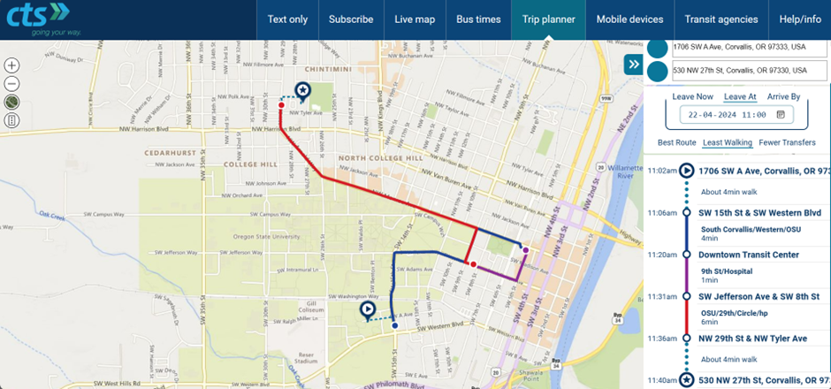

Fig 2.1:Corvallistransit.com – After entering all details the website displays a map on LHS indicating walk by dotted lines and using different color for different transfers. RHS shows a detailed Itinerary with the timeline.

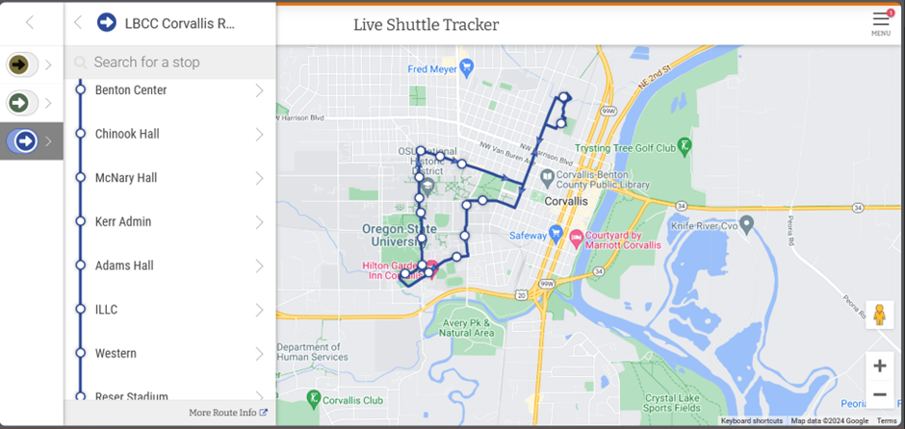

Fig 2.2: osushuttles.com – On selection of the route followed by the user can see timing of the next shuttle arriving at the selected stop. RHS displays the route that the shuttle follows.

1. Explain the benefits of using new and existing features (Motivations and Attitude Toward Risk)

The screen displays the "LBCC Corvallis Route" option, suggesting the availability of a multi-modal route feature. However, the unique benefits of this route, such as potential time savings or fewer transfers, are not explicitly explained, which may not motivate users to explore it.

1. Explain the costs of using new and existing features (Attitude Toward Risk)

No information is provided about potential costs or trade-offs associated with using the "LBCC Corvallis Route" option, such as additional fare costs or longer travel times, which may concern risk-averse users.

1. Let people gather as much information as they want, and no more than they want (Information-Processing Style)

The screen provides a map view of the selected route, catering to users who prefer visual information processing. However, there are no immediate options for comprehensive information gatherers to access more details about the route, such as schedules or transfer points.

1. Keep familiar features available (Computer Self-Efficacy and Attitude Toward Risk)

The screen displays the familiar "Northeast Route" option, allowing users with lower self-efficacy or risk-aversion to continue using the app as they have in the past.

1. Make undo/redo and backtracking available (Attitude Toward Risk)

The screen does not appear to provide options to undo or backtrack from the selected route option, which may concern risk-averse users who want the ability to easily revert their choices.

1. Provide an explicit path through the task (Learning: by Process vs. Tinkering)

The screen presents the map view of the selected route as the next step after choosing the route option, providing a clear path for process learners to follow.

1. Provide ways to try out different approaches (Computer Self-Efficacy)

By displaying the "Northeast Route" option alongside the "LBCC Corvallis Route," the screen allows users with varying levels of self-efficacy to explore different route approaches.

1. Encourage tinkerers to tinker mindfully (Learning: by Process vs. Tinkering)

While tinkerers may be inclined to switch between different route options, the screen does not provide specific guidance or reminders to help them focus on the most relevant or efficient choice for their commute needs.

1. Detailed Itinerary and Confirmation:

Image 1: Detailed Itinerary - Northeast Route & Image 1: Detailed Itinerary - LBCC Corvallis Route

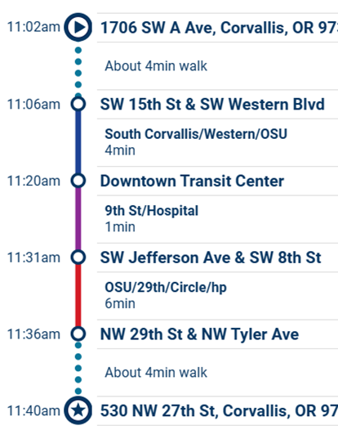

Fig 3.1 : Corvallistransit.com – Screen 2 shows the detailed Itinerary and map. Confirmation page is absent.



Fig 3.2: osushuttles.com – No confirmation or Itinerary available. Clicking on More route info leads to the above blank screen.

1. Explain the benefits of using new and existing features (Motivations and Attitude Toward Risk):

The screen does not explicitly highlight the benefits of the selected "Northeast Route" option or explain why this route was recommended over other options, such as the multi-modal "LBCC Corvallis Route." Users may not be motivated to confirm this selection without understanding its advantages.

1. Explain the costs of using new and existing features (Attitude Toward Risk):

No information is provided about potential costs or trade-offs associated with using the "Northeast Route," such as travel time or number of transfers, which may concern risk-averse users before confirming the selection.

1. Let people gather as much information as they want, and no more than they want (Information-Processing Style):

The screen provides a detailed itinerary with the stop names for the selected route, catering to comprehensive information gatherers who prefer to have all the details before proceeding. However, there are no options for selective information processors to access a concise summary or overview.

1. Keep familiar features available (Computer Self-Efficacy and Attitude Toward Risk):

The screen displays the familiar "Northeast Route" option, allowing users with lower self-efficacy or risk-aversion to continue using the app as they have in the past.

1. Make undo/redo and backtracking available (Attitude Toward Risk):

The screen does not appear to provide options to undo or backtrack from the selected route, which may concern risk-averse users who want the ability to easily revert their choices before confirming.

1. Provide an explicit path through the task (Learning: by Process vs. Tinkering):

The screen presents the detailed itinerary as the next step after selecting the route, providing a clear path for process learners to follow. However, there is no explicit guidance on how to proceed after reviewing the itinerary.

1. Provide ways to try out different approaches (Computer Self-Efficacy):

The screen does not appear to provide options to explore or compare alternative route approaches, which may not cater to users with varying levels of self-efficacy who want to try different options.

1. Encourage tinkerers to tinker mindfully (Learning: by Process vs. Tinkering)

While tinkerers may be inclined to explore different route options, the screen does not provide specific guidance or reminders to help them focus on the most relevant or efficient choice for their commute needs.